PYCTS Primer for Students

**What is PYCTS?**

PYCTS is web software that allows student to quickly and easily check the number of research credits they have earned. PYCTS can also be used to check what research studies are currently being offered to students.

**Where is PYCTS?**

PYCTS can be found at the following URL:

http://pycts.clarkson.edu

**How do I check my credits?**

Open a browser and go to the URL above, then log in using your Clarkson username and password. This is the same username and password used to access other Clarkson web resources (such as Moodle and Peoplesoft). Upon logging in, the student will be sent to the **Report** tab. There they will see a table detailing any credits they have received - each entry corresponds to one study or miscellaneous credit assignment.

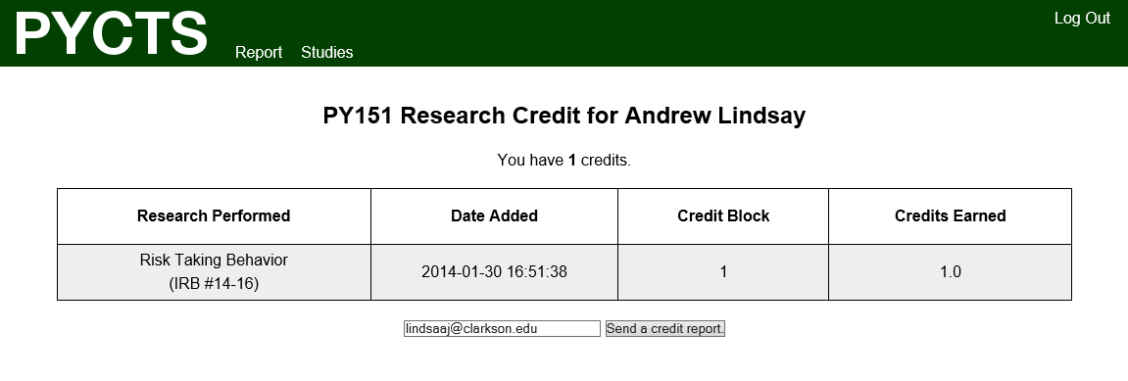

Figure 1: A sample credit report

**How can I get a copy of my credit report?**

To email yourself (or anyone else) a copy of your credit report, provide an email address in the field at the bottom of the main page once logged in and click the button to have a credit report sent to the provided address.

**What happens when credits are added for me?**

When a new credit entry is made for you two things will happen. The first is that the entry will be added to your sum total and displayed along with your other credits upon logging in. The second is that an email will be sent to you informing you of this addition.

**What happens when credits are removed from my record?**

When a credit entry is removed from your record two things will happen. The first is that the entry will no longer be added to your sum total and displayed along with your other credits upon logging in. The second is that an email will be sent to you informing you of this removal.

**How can I find out what studies are available?**

To view current credit opportunities, navigate to the **Studies** tab after logging into PYCTS. This page will display all research studies currently being offered to students. For each study, there is link to a flyer containing more information (including a contact email address or phone number). To schedule an appointment with the relevant lab, contact the given email address or phone number.

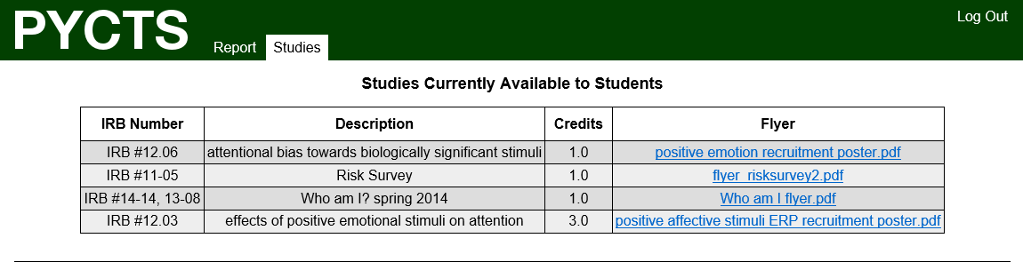

Figure 2: A sample studies page

**What happens when a new block starts?**

When a new block starts, any credits earned on or after that date will be assigned to the new block. There are ways for the block assignment to be overwritten, but this will only happen given unusual circumstances. In general, the blocks are designed so that students must participate in a minimum amount of research during each period of the semester.

**What happens when a new study is made available?**

When a new credit study is made available two things will happen. The first is that the new study will be shown under the **Studies** tab once logged in. The second is that an email will be sent to you informing you of this new credit opportunity.

PYCTS Version 1.0